1. 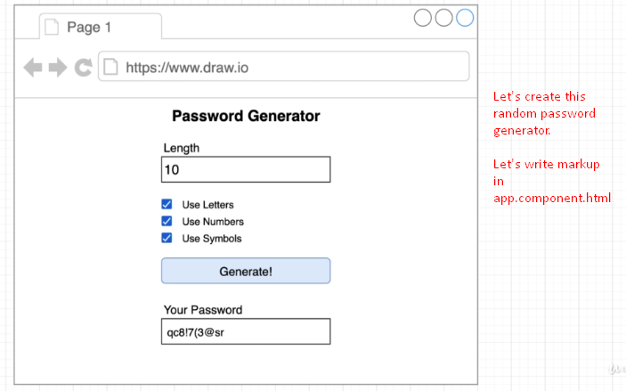
2. 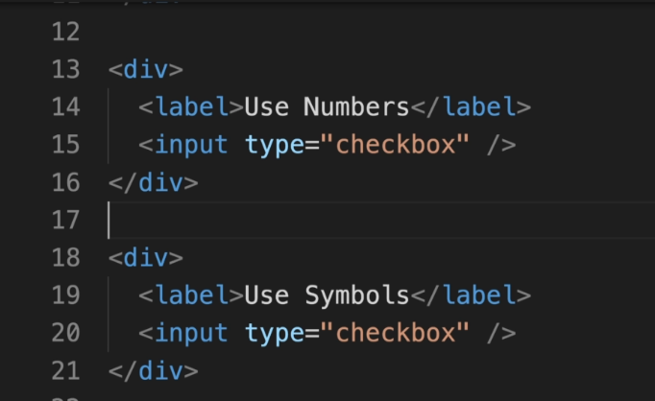  
   Jatin: You write the markup yourself as you know and hit is use <div> instead of <br />